The Dorchester Team Arrives for a Summer Visit – July 2022

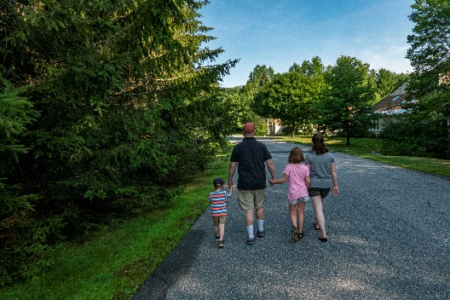Steve and Marie with our grandkids, Evie and Daniel, joined us for a very warm weekend in July. It was great gathering with all of us and we caught up on life here and there. After settling in we headed to the Association pool for a good cooling off and closed her up as we were the last ones out. Sunday after breakfast we all took a morning 2.5 + mile hike up the “under construction” modernization of the wooded path up to the former railroad - current rail trail. After that we hit the pool for a good time. And our good neighbors, Jon & Meg, joined us on the walk and pool ventures. A very nice easy weekend and to be continued…

And for some photos, click on the [Dorchester Team Arrival -2022.pdf](https://photos.app.goo.gl/qARj3sMZTwdWGD8F8) and feel free to enlarge.